

**LEWACH**

**A Goods Exchange Platform**

ARBAMINCH INSTITUTE OF TECHNOLOGY (AMIT)

(ARBA MINCH UNIVERSITY)

Abdulahi Muhammed RAMIT/031/11

Biniyam Zeleke RAMIT/460/11

Mihret Tekalegn RAMIT/1307/11

Selemon Chebeso RAMIT/1630/11

Sisay Kebede RAMIT/1679/11

Mr. Dawit Mekonen

Submitted to Department of Software Engineering, Faculty Computing and Software Engineering, AMIT, Arba Minch University, in Partial fulfillment for the requirement of the Degree of Bachelor Science

# Abstract

This document outlines a new project proposal for an online goods exchange website called “Lewach”. Lewach, a traditional trading system of commodities exercised in Ethiopia, is one part of the day to day activities of the Ethiopian community. But this current system has some problems like lack of variety of goods available at constant location, wastage of time and money of traders, lack of guaranteed safety of the traders during their trips to make this trade, and the improvised version of this Lewach system only makes trade of used commodities for new ones which may be not ideal for all traders. The objective of this project is to establish a secure and user-friendly platform that allows traders to efficiently and effortlessly transact. The platform will be designed with the highest standards of security, user experience, and scalability to ensure the highest levels of satisfaction among all users. This document intends to provide a comprehensive overview of the project's scope and main objectives, as well as a clear understanding of the potential risks and rewards associated with implementing the project. The project has been fashioned to create an efficient and reliable system for users to exchange goods. The platform will include a sophisticated search engine system to ensure that buyers can find the goods they are looking for quickly and easily. Additionally, it will feature a rating system to ensure that buyers can trust the current quality of the goods being sold. This project will be conducted with a customer to customer(C2C) e-commerce model.

Contents

Abstract 2

Background of Institute/University 2

Background of the Project 3

Team Composition 4

Tasks and Schedule 4

Problem statement 5

Detailed Objectives of the Project 6

General objectives of the Proposed Project 6

Specific objectives of the Proposed Project 6

The website will have the following features: 6

Scope of the Project 7

Feasibility 8

Operational Feasibility 9

Political Feasibility 9

Economic Feasibility 9

Methodology 9

Data Source 9

Fact-finding Techniques 10

Analysis and Design Approach 10

Overview of Project Phases 11

Artifacts to Produce 11

Inception phase 11

Elaboration Phase (SRS-System Requirement Specifications) 12

Bibliography 15

**List of Tables**

Table 1 : Team Composition 4

Table 2 : Tasks and Schedule 4

Table 3 : Development Tools 13

# Introduction

Wastage of commodities in countries like Ethiopia is not something that we can see and look the other way. In many households around the country and individually people hold on to things that they don’t have use for but also don’t throw out because of the inability of their conscience to allow them to dispose of something they spent money on, money which they acquire in difficult circumstances, that easily.

## Background of the Project

The Lewach trading system originated in the time of the early Ethiopians sometime between the 4th and 7th centuries AD. It was a barter system of exchange which allowed people to exchange goods and services without using currency. This system would be used until it was replaced by a cash-based economy in the late 19th century.

But this system didn’t disappear totally. In one way or another, this system is still being used in Ethiopia in the so-called "lewach-lewach" literally meaning 'exchange-exchange'. In this "lewach-lewach", people exchange their old clothes and old shoes with drinking glasses and other household utensils.

## Team Composition

|  |  |  |
| --- | --- | --- |
| No. | Name | Responsibility |
| 1 | Abdulahi Muhammed | Software Developer/ Software Architect/ Business Analyist |
| 2 | Biniyam Zeleke | Software Developer/ Project Manager/ UI/UX Designer |
| 3 | Mihret Tekalegn | Software Developer/ UI/UX Designer/ Project Manager |
| 4 | Selemon Chebeso | Software Developer/ Business Analyist/ Tester |
| 5 | Sisay Kebede | Software Developer/ Tester/ Software Architect |

Table 1: Team Composition

## Problem statement

Holding on to things we don't use most often can be a problem for a few different reasons. Firstly, it can lead to clutter in our homes, which can be a source of stress and anxiety. It can also be a waste of valuable space that could be used for more productive purposes. Secondly, it can be a waste of money if we are holding onto items that we could have sold or donated to someone else who could use them. Lastly, it can be a waste of time if we are constantly having to search through our possessions to find something we need. All of these reasons can lead to a feeling of being overwhelmed and can prevent us from living a more organized and efficient life.

At the moment in order to remedy this problem the current version of lewach, which exchanges old commodities with new ones, is implemented. The Lewach trading system has been in place for centuries and is an important part of the country’s economy. However, there are some drawbacks to this system.

* One of the main drawbacks of the Lewach trading system is that it is largely unregulated. This means that there is no oversight or regulation of the transactions that take place, which can lead to exploitation and unfair practices. For example, there is no guarantee that the goods being traded are of good quality, or that the prices are fair. This can lead to people being taken advantage of and not receiving the value they expect for their goods.
* Another drawback of the Lewach trading system is that it is limited in scope. This means that it is difficult to access a wide variety of goods, as the traders are limited to the goods that are available in their local area. This can lead to a lack of choice and variety for consumers, as well as limited access to goods from other parts of the country.
* This system is often considered primitive and inefficient. This is due to the fact that traders must use manual labor to bring goods over long distances and usually can not access the latest technologies or international markets. Additionally, the lack of reliable infrastructure inhibits the ability of traders to transport goods quickly and economically
* It is also inefficient in terms of maintaining accurate record-keeping of goods. This often leads to disputes over payments and makes it difficult to determine the fair value of goods.
* Finally, the Lewach trading system is not very efficient. This means that it can take a long time for goods to be traded and for people to receive what they need. This can lead to delays in getting goods, which can be costly for businesses and individuals.

## Detailed Objectives of the Project

### General objectives of the Proposed Project

The general objective of this project is to develop a goods exchange platform.

### Specific objectives of the Proposed Project

* To develop a user-friendly interface for customers to easily search for goods
* To create a platform where users can trade commodities of their choices.
* To develop an efficient delivery system for customers to receive exchanged goods
* To reduce time spent on exchanging items/goods that are associated with manual handling.

## Scope of the Project

The scope of the goods exchange website is to provide an online platform for people to exchange goods. The website will allow users to create their own profiles, browse product listings, and post their own listings. It will also offer features such as messaging and payment gateways so users can securely complete their transactions. The website will also provide a platform for users to connect with one another and exchange feedback and ratings on their experiences. The goal of the website is to provide a safe, secure, and reliable way for people to exchange goods online.

## Feasibility

This website is a platform that allows people to exchange items. It is a great way to save money and reduce waste. The feasibility of the website depends on several factors, including the size of the market, the availability of goods, the cost of running the website, and the demand for the goods.

### Operational Feasibility

The website will have a secure, user-friendly platform that allows users to list and browse items. The website will also provide features that allow users to contact each other, arrange payments, and track shipment status.

### Political Feasibility

The website being developed does not contradict any political issues and ideas. It will need to abide by all applicable laws and regulations. This would include complying with any relevant consumer protection laws.

### Economic Feasibility

This project will be economically feasible as it will have a business model that is financially sustainable. This could include charging a fee for ad space, as well as taking a commission from successful transactions. Additionally, the website will have a good return on investment, and will be able to generate a profit over time.

### Technical Feasibility

### Schedule Feasibility

|  |  |  |  |  |  |  |  |  |
| --- | --- | --- | --- | --- | --- | --- | --- | --- |
|  | **Time Period** | | | | | | | |
|  | **Jan 6- Jan 13** |  |  |  |  |  |  |  |
| Proposal |  |  |  |  |  |  |  |  |
| Description of current system |  |  |  |  |  |  |  |  |
| Data Gathering |  |  |  |  |  |  |  |  |
| System Analysis |  |  |  |  |  |  |  |  |
| System Design |  |  |  |  |  |  |  |  |
| System Implementation |  |  |  |  |  |  |  |  |
| System Testing |  |  |  |  |  |  |  |  |

Table 2: Tasks and Schedule

# Methodology

## Data Source

1. Online surveys of existing goods exchange websites, such as Craigslist, eBay, and OfferUp.

2. Interviews with users of existing goods exchange websites to understand their experiences and needs.

3. Data from online search engines to understand user search patterns related to goods exchange websites.

4. Social media data to understand user sentiment towards existing goods exchange websites and their features.

5. Data from customer service inquiries related to existing goods exchange websites

## Fact-finding Techniques

**Interviews:** Interview stakeholders, customers, and other experts to gain insights into the needs and expectations of the project.

**Surveys:** Create surveys to collect data from customers and other stakeholders about their needs and expectations for the project.

**Focus Groups:** Gather a group of stakeholders or customers to discuss their needs and expectations for the project.

**Observation:** Observe how customers use existing goods exchange websites to gain insights into what features they would like to see in the proposed website.

**Document Analysis:** Analyze existing documents related to goods exchange websites, such as user manuals, customer feedback forms, and competitor websites, to gain insights into customer needs and expectations for the project.

# Analysis and Design Approach

**Development Tools**

|  |  |
| --- | --- |
| Activities | Tools/ Programs |
| Client side coding | HTML/CSS |
| Client side scripting | JavaScript/React |
| Platform | MS Windows or Linux |
| Database server | MySQL |
| Web server | Apache |
| Server-side scripting | PHP |
| Browsers | Google Chrome |
| Editors | Microsoft VS Code |
| Documentation | MS Word, MS Excel |
| User Training | MS PowerPoint, Video Player |
| Varied technologies | As per the technical requirement in future |

Table 3: Development Tools

**Limitation of the Project**

The proposed project has some limitations that should be taken into account. Some of these limitations include:

* Shipping cost – The cost of shipping items can be expensive, depending on the size and weight of the product.
* Quality – Since goods exchange websites involve an exchange of used goods, the quality of goods can vary significantly.
* Time – It can take a while for goods to be exchanged, depending on the size of the goods and the distance between the two people involved in the exchange.
* Security – When exchanging goods online, there is always the risk of fraud and the possibility of scams.
* Limited selection – Depending on the size of the network of users, the selection of goods available may be limited.

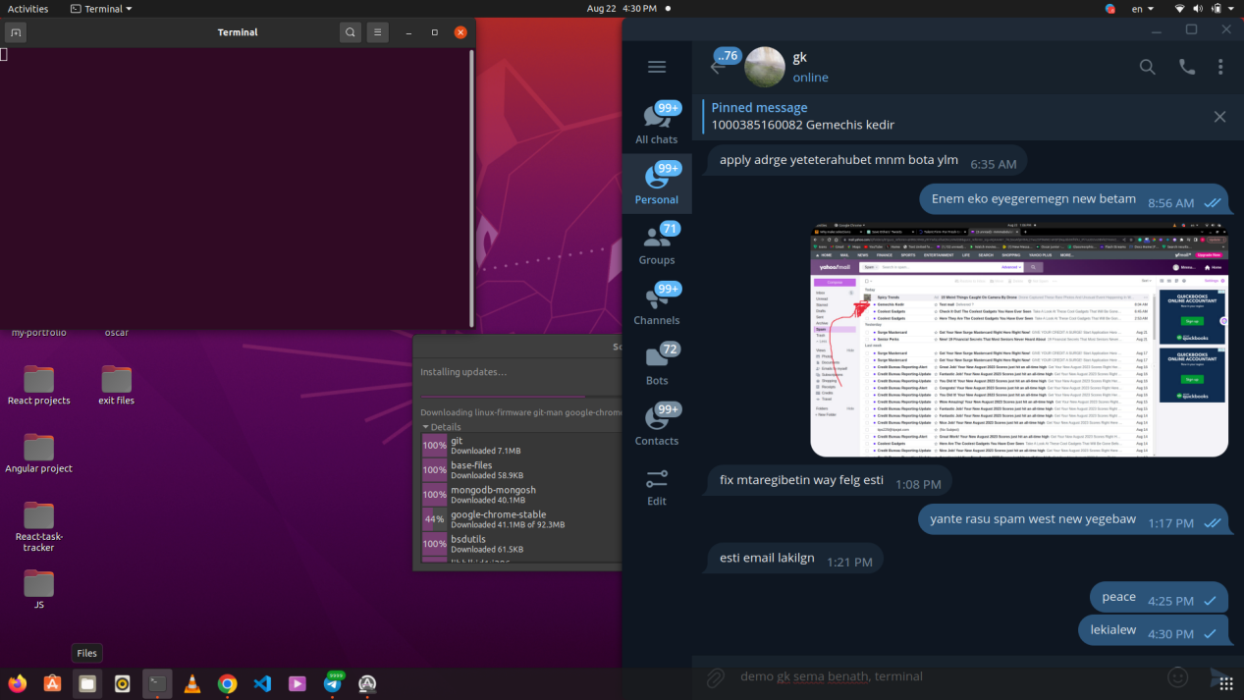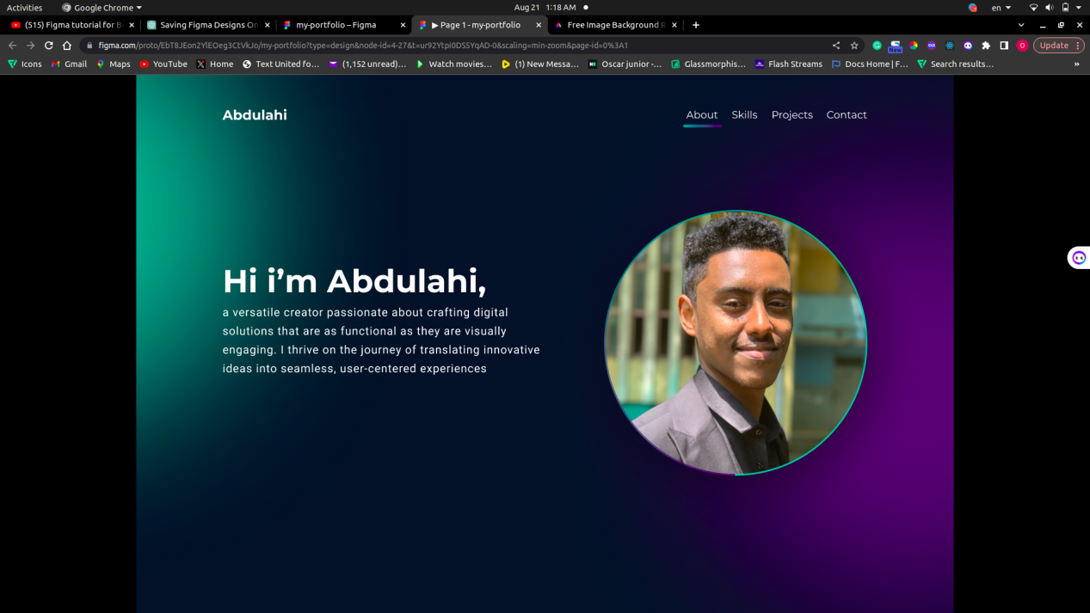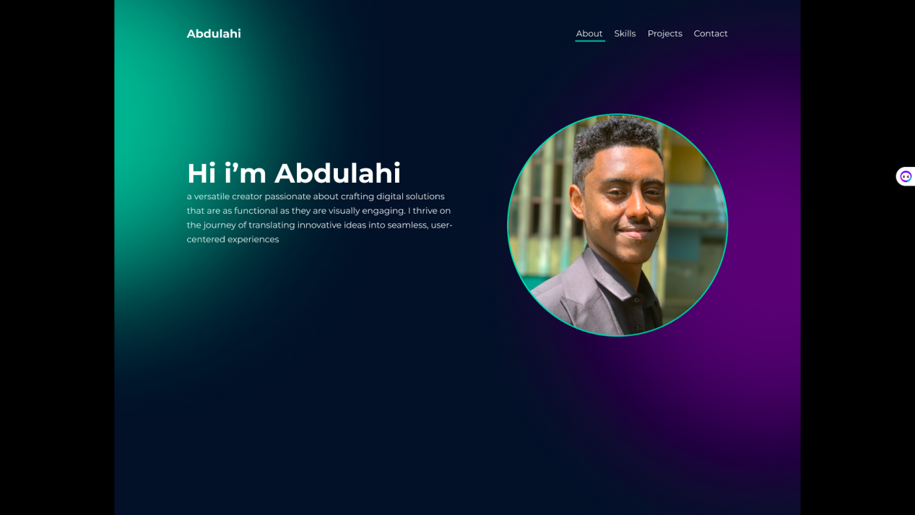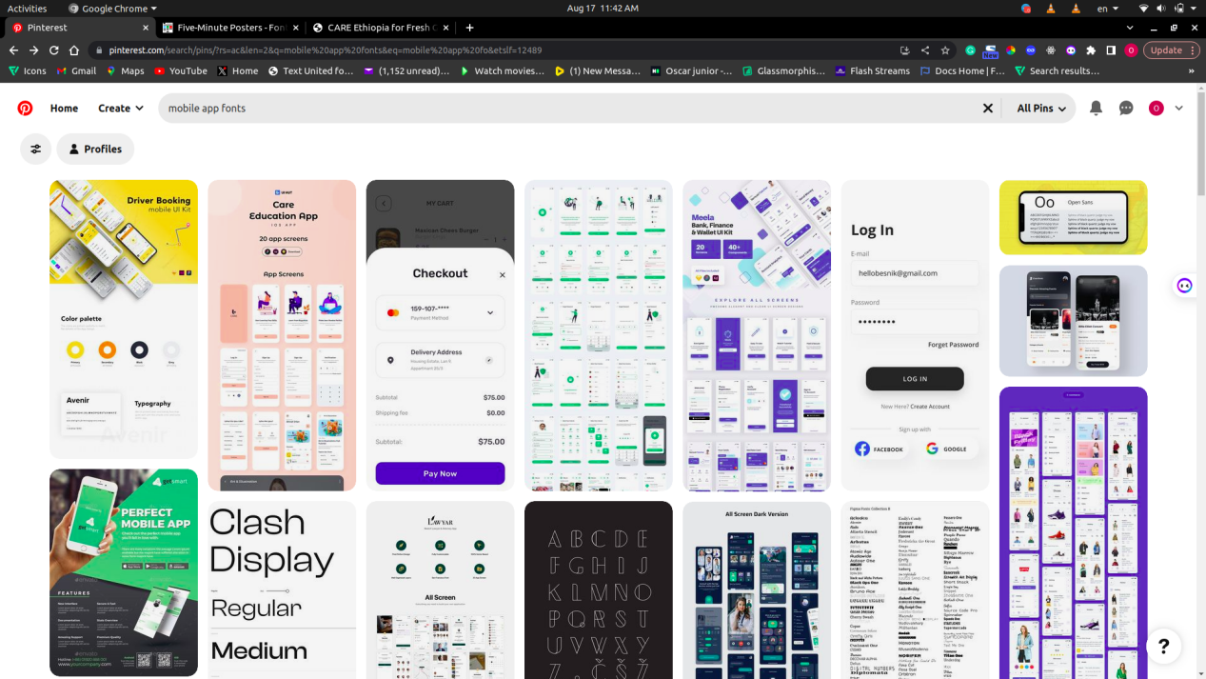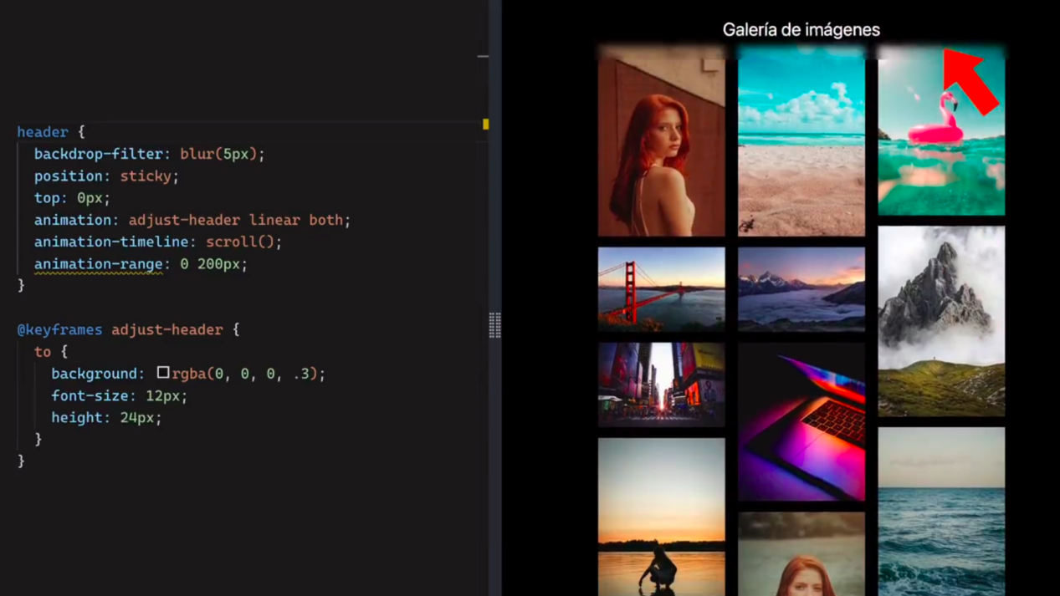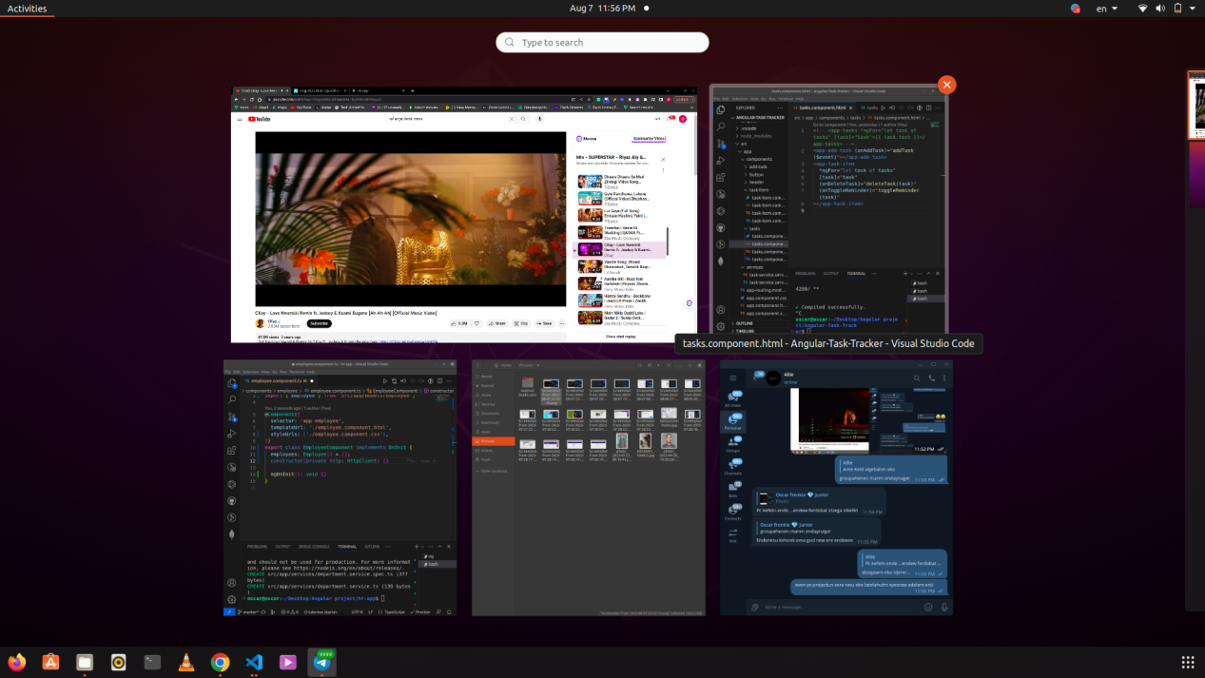

# Bibliography

(n.d.). Retrieved from https://en.wikipedia.org/wiki/Arba_Minch_University.